**Ideation Phase**

**Define the Problem Statements**

|  |  |
| --- | --- |
| Date | 27 June2025 |
| Team ID | LTVIP2025TMID30720 |
| Project Name | smartsdlc – ai-enhanced software development lifecycle |
| Maximum Marks | 2 Marks |

**Customer Problem Statement :**

Modern software development teams face significant challenges in managing the Software Development Lifecycle (SDLC) efficiently. Key stages such as requirement gathering, code generation, debugging, testing, documentation, and team communication are often siloed, manually intensive, and error-prone. This leads to project delays, inconsistent output quality, increased operational costs, and decreased team productivity—especially when translating unstructured client requirements into actionable development.

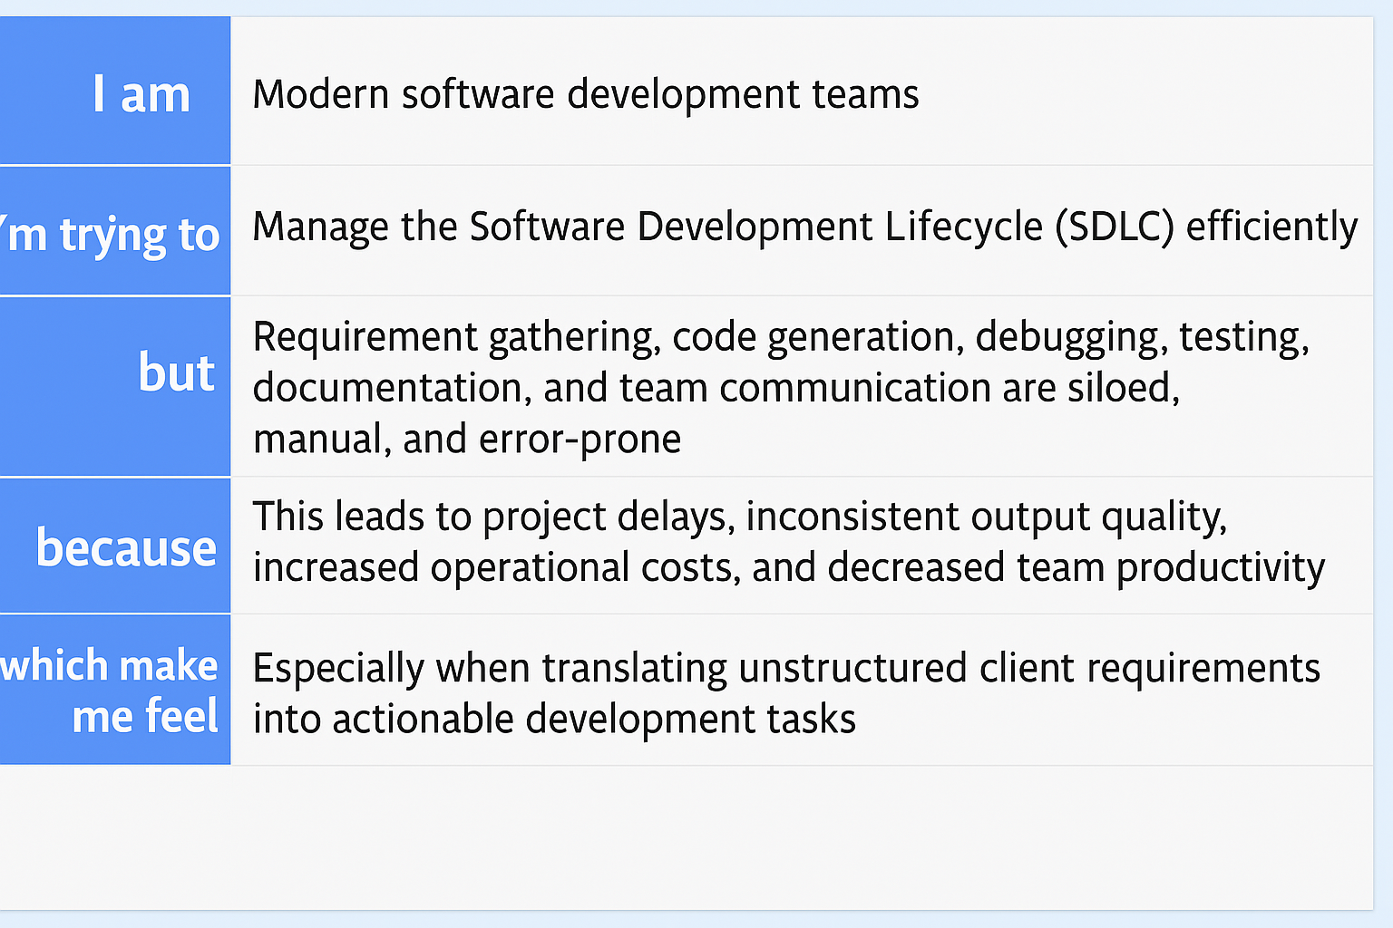

Reference::👉 [Using SDLC in Development – Scientific Diagram on ResearchGate](https://www.researchgate.net/figure/Using-SDLC-in-Development_fig2_318490613)

**Example:**

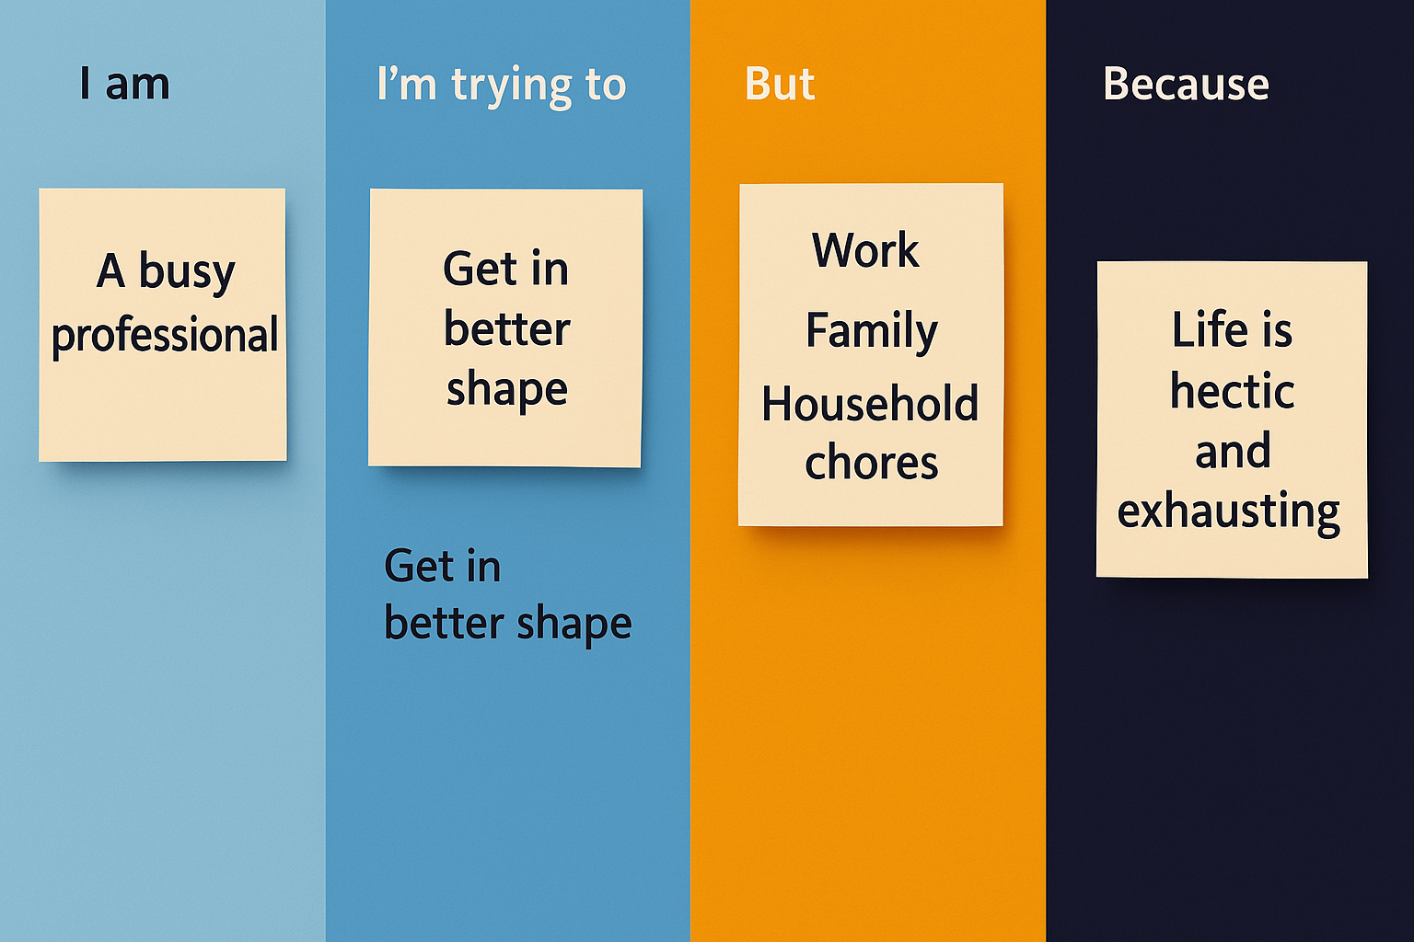

|  |  |  |  |  |  |
| --- | --- | --- | --- | --- | --- |
| **Problem Statement (PS)** | **I am (professional)** | **I’m trying to** | **But** | **Because** | **Which makes me feel** |
| PS-1 | A backend developer exploring Spring Boot and system design | Build scalable, production-ready applications | I'm juggling complex configurations and time constraints | I’m still mastering the ecosystem and managing other studies | A bit overwhelmed but eager to grow |
| PS-2 | A curious AI/ML enthusiast with a knack for problem-solving | Deepen my understanding of Transformers and generative models | The concepts get really abstract without hands-on intuition | I'm learning mostly through self-guided study | Challenged yet inspired to keep pushing |